2. Step: Niche & Keyword Research SOP

This is the overall process for researching a niche and conducting great KW research.
Choosing the right niche lays the foundation for long-term success and ensures that you have a consistent pool of 50–100 strong keywords.

Key Definitions:
- Niche: A specific market segment you target (e.g., Home Decor, DIY & Crafts).
- Keyword (KW): The search term or phrase that users enter on Pinterest.

Niche Research SOP:
- Go to Pinterest > Audience Insights
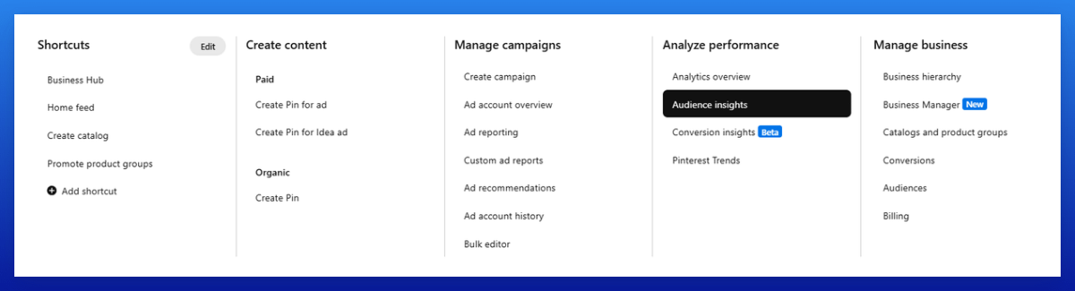
- Go to 'All Pinterest Users' and check out the different categories and their interests.
Look for ones big enough to build a dedicated site around.
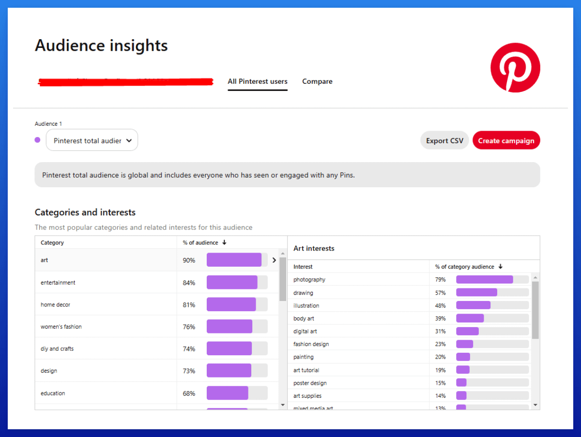
- A niche should be big enough to provide 50–100 strong keywords for articles over the long term and should provide diverse subtopics.

These are my top 10 niches:
- Fashion
- Art & Design
- Beauty
- Home Decor
- DIY & Crafts
- Wedding
- Food & Recipes
- Architecture
- Parenting
- Gardening

Keyword Research SOP:
- Create a tab in your overview sheet and name it "KW Research."
- List all broad topics that come to your mind for your site there, like room decor or kitchen.
- Enter these broad topics into Pinterest's 20k largest interest database here:
https://www.pinclicks.com/interests.html.
Add relevant interests to your overview sheet.
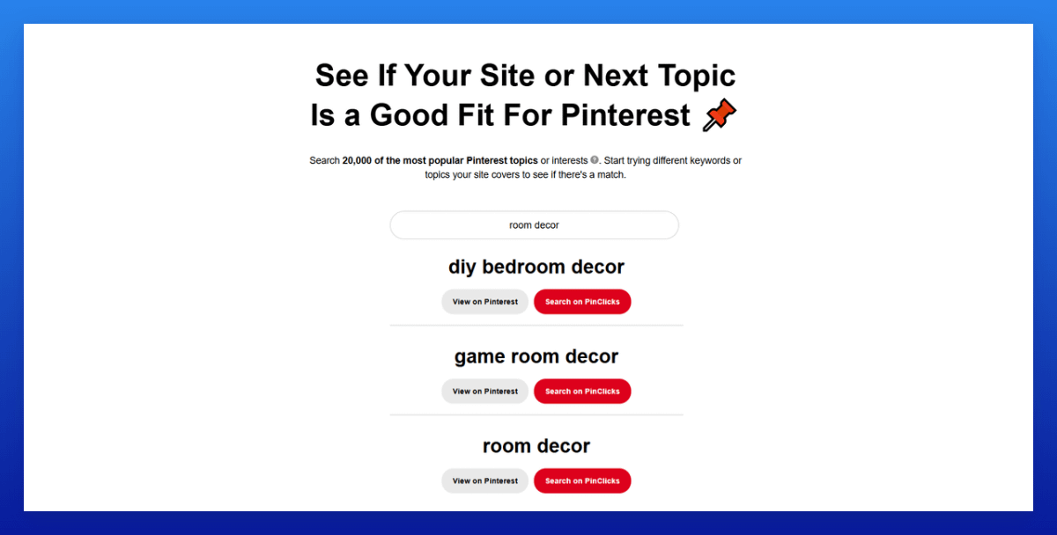
- Use Pinclicks* > Interest Explorer and input those large interests.
Look for additional interests with at least >5-10k volumes and add these to the sheet.
(You can also add interests with smaller volumes if you want)
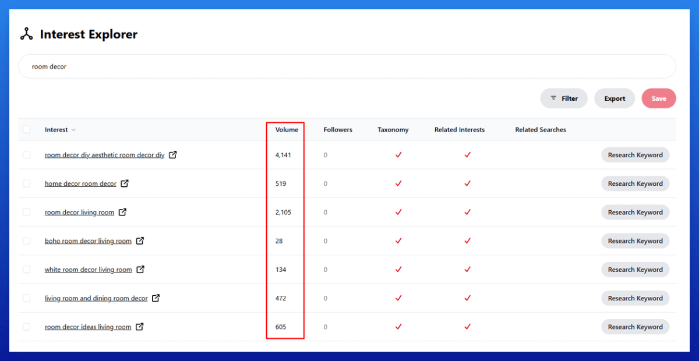
- Skip seasonal KWs unless the season aligns soon. I focus on evergreen keywords because they’re easier to manage with multiple sites.
Seasonal KWs require starting 2–3 months in advance, which means extra management effort.
My goal is to keep my processes as simple and streamlined as possible, so evergreen KWs are more efficient if the niche has enough good ones of them.
- Use Pinclicks* > Keyword Research to find even more variations.
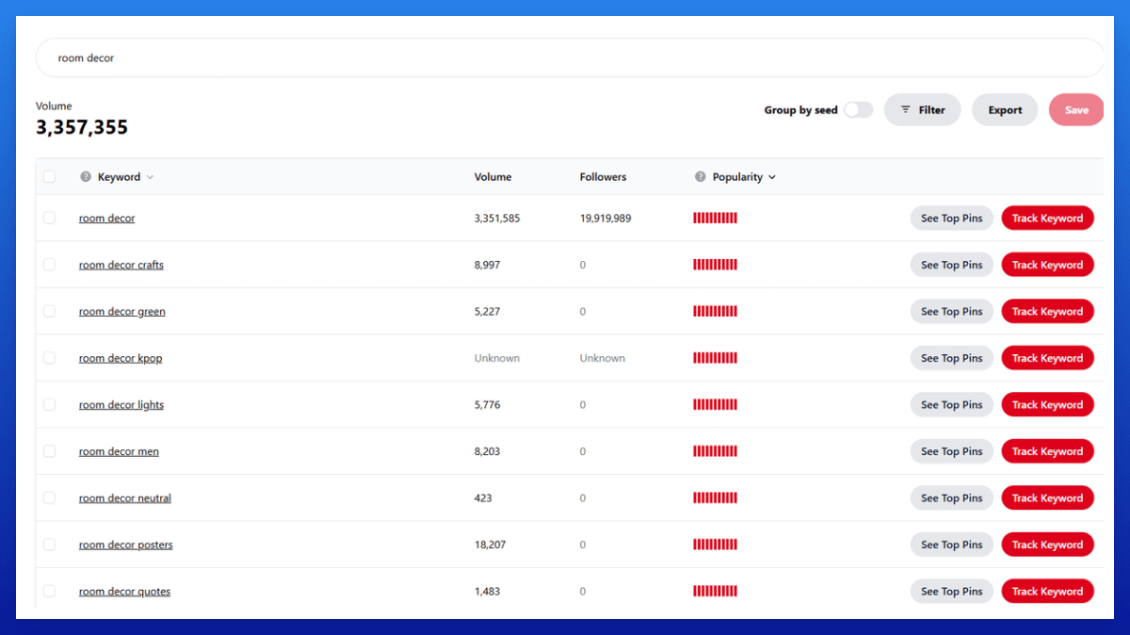

Tips:
- For many broad KWs, you can add "ideas" or "designs" to easily create long-tail KWs with less competition.
- I like to add a great mix of broad KWs (higher probability of short-term spikes) and smaller long-tail KWs (easier to rank for, less competition).
*(Aff link, we earn a commission if you make a purchase, at no additional cost to you. Use the coupon code "nichegrownerd" to get 25% OFF)

